Chapter 11, Solution 58.

Obtain the complex power delivered to the 10-kΩ resistor in Fig. 11.77 below.

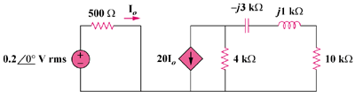

Figure 11.77
For Prob. 11.58.

Solution

From the left portion of the circuit,

which then leads to the following circuit,

j1 k

10 k

-j3 k

8 mA

I_{x}

4 k

From the right portion of the circuit,

It should be noted that the complex power delivered to a resistor is always watts.

